**Locating Appropriate Features in Data for AI Bot**

Use AI baselines - ai algorithms that we can use to run over the API

Step-By-Step on how to run the Pysc2 examples: <https://www.youtube.com/watch?v=URWXG5jRB-A>

By training over sample data, the computer should have a good understanding of the most suitable tip that should be provided - P(T|S) - with “T” being the set of all tips and “S” being the set of all game states. This will accelerate the magnitude of usefulness of each tip for the user.

**Overview of Ideas For Tips:**

* The tip may come in the form of a slide-in header that covers part of the corner of the screen if there is a tip
* Each tip can have a level of urgency, with the higher the urgency of the tip, the higher amount of attention that it will require from the user *(magnitude depends on how likely the issue will cause the gamer to lose - could apply machine Object/Dictionary, which have instant search-up time)*
* Provide the user with some of the **best build orders** so that could follow how games are successfully won (*Created in the form of a checklist, with each item in the checklist being completed upon successful completion of the specified task in the checklist. Example found below:*

|  |  |  |  |
| --- | --- | --- | --- |
| *13* | *0:18* | *Pylon* |  |
| *15* | *0:39* | *Gateway* |  |
| *16* | *0:49* | *Assimilator* |  |
| *20* | *1:26* | *Nexus* |  |
| *20* | *1:37* | *Cybernetics Core* |  |
| *21* | *1:46* | *Assimilator* |  |
| *22* | *1:55* | *Pylon* |  |
| *22* | *2:05* | *Adept* |  |
| *26* | *2:18* | *Warp Gate* |  |
| *27* | *2:33* | *Stargate* |  |
| *27* | *2:34* | *Stalker* |  |
| *33* | *3:07* | *Oracle* |  |
| *33* | *3:12* | *Zealot* |  |
| *40* | *3:34* | *Oracle* |  |
| *41* | *3:44* | *Assimilator* |  |
| *45* | *3:48* | *Assimilator* |  |
| *46* | *3:57* | *Pylon* |  |
| *46* | *4:05* | *Gateway x2* |  |
| *46* | *4:15* | *Phoenix* |  |
| *50* | *4:27* | *Robotics Facility* |  |
| *50* | *4:29* | *Pylon* |  |

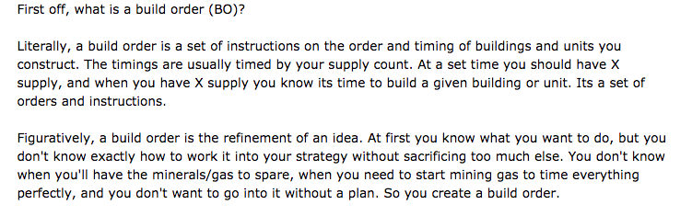

* Learning how to read build orders: <http://imbabuilds.com/guides/how-to-read-build-orders/>
* Examples of build orders:

<https://lotv.spawningtool.com/build/>

**Listeners AI Bot Will Have:**

* Focus on supply of minerals
* Number of workers
* Economy and army
* Number of workers versus opponent - the difference between both
* Number of bases completed
* How many hatcheries as a zerg?
* Number of gateways for protos
* Look at the different types of units that each side has and check to see if there is a significant advantage that the opponent or you may have against the opponent (air attack, faster ground attack, etc.)
* Update the user on the moment that the army deficit is significant to the point that the user has a significant chance of losing if a certain route is not take *(Can apply machine learning techniques to see what the deficit would look like after analyzing professionals, AS WELL AS inform the user of the actions they should take based on the successful actions that winners have taken to counteract such issues)*
* Compare the actions per minute of each player to inform the user in the form of a tip the moment that the opponent is gaining an upper hand by having more actions per minute than you, which could be foreshadowing a loss due to the user slowing down and the opponent making more progress
* During middle of fights and battles, or attacks, AI bot can tell you when to retreat and when to continue to attack - based on the likelihood of the user winning a battle against the opponent given the opponent that the user is facing, the amount of soldiers available - *(don’t want to lose too many soldiers in the long run) -* etc.

**Tips Based On Scouting Probes:**

* If a scouting probe sees that there is an enemy, the tip/highlight should then pop up to inform the user that:
  + There is an enemy up ahead
  + The type of enemy that was spotted
  + The number of enemies that were spotted
  + Pinpoint the exact location in which the enemies were spotted
  + type of **units** he has, what type of **units** he is currently capable of producing, and what type of **units** he may be working towards in the future. When you know all of those things you will be able to make better decisions on where to allocate your resources.

**Tips Based On Overall Game:**

* During the beginning/throughout the game, the user can be informed of what their respective army is good at based on analyzed data sets (are the zergs/protos more mobile or defensive, what is the best formation when exploring and advancing, etc.)

**Attack Techniques That User Can Be Informed of Mid-Battle:**

* Flank
* Spread
* Surround - not just attacking the frontmost units but also attacking around them so you can do more attacks at a given time
* High-value units in back and low value melee units in front
* When to consider **dancing** technique (retreating individual units that are taking fire and then bringing them back when they are no longer under attack)